EXPERIMENT 12

12.1.1// Remove Punctuations from a String
ALGORITHM:
Step 1: Start
Step 2:
Input an integer n (number of operations)
Step 3: Create an empty dictionary ph to store contacts
Step 4: Repeat the following steps n times:
Input a command and split it into parts → cm
If cm[0] == "ADD" then
- Store the contact in dictionary
- ph[cm[1]] = cm[2]
Else if cm[0] == "REMOVE" then
- Remove the contact if it exists
- ph.pop(cm[1], None)
Else if cm[0] == "DISPLAY" then
- If dictionary is empty
  - Print "No contacts"
- Else
  - Sort all names in ascending order
  - For each name in sorted list:
    - Print name: phone_number
Step 5: Stop

FLOWCHART:
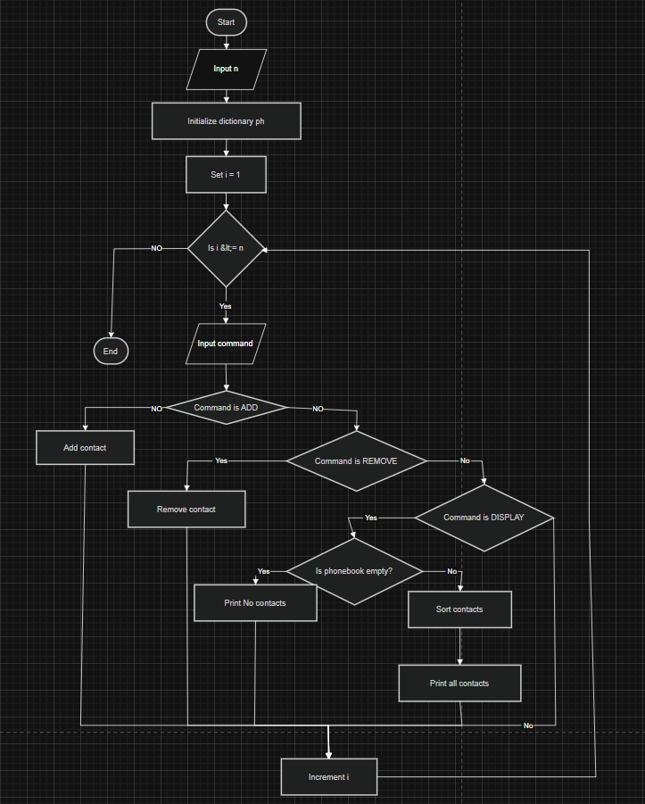

CODETANTRA:
